# **COMPUTER NETWORKS PRACTICE**

## **Online Examination Simulator**

## 

## 

## 

## 

### 

### 

### 

### **Assignment By:**

**1.Sree Sai Sankalp Jagadam — 120CS0006**

**2.Himanshu Mahaur — 120CS0007**

**3.Vinod Kumar — 120CS0008**

**4.Mallela Nithesh Raj — 120CS0009**

**5.Abhineeth Babu — 120CS0010**

### 

### **Guidance By:**

**Anil Kumar Sir**

## Application Workflow :

### 1. User Login :

Users can login using their username and password.

Credentials will be provided by the examiner.

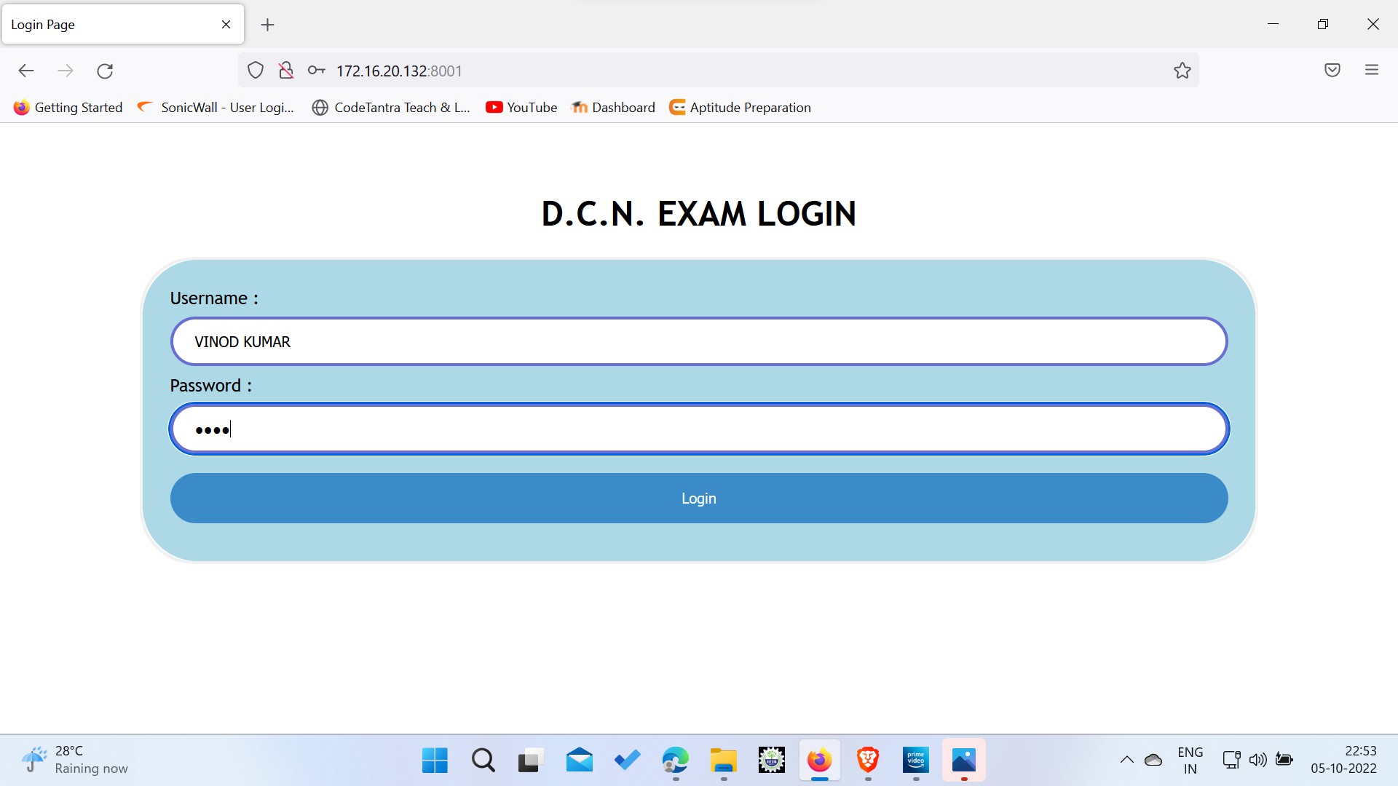

### 

### 

### 

### 2. Attempt the test :

Only a limited amount of time is provided for exam.

Results will be automatically generated once time runs out.

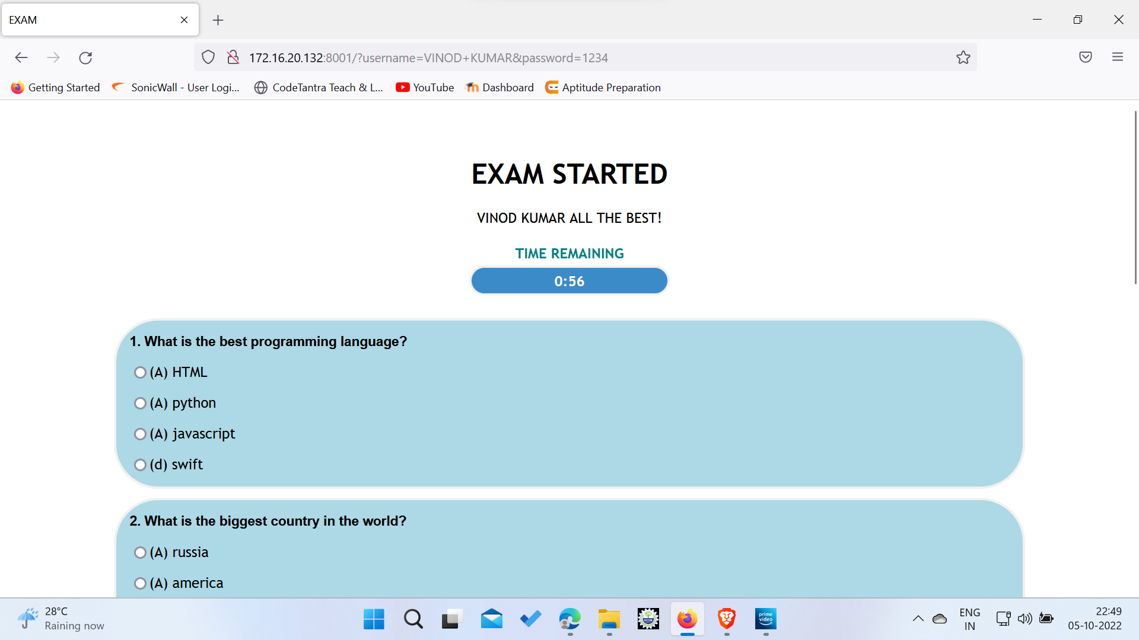

### 

### 

### 

### 

### 3. View the Responses :

The selected option is marked with blue color.

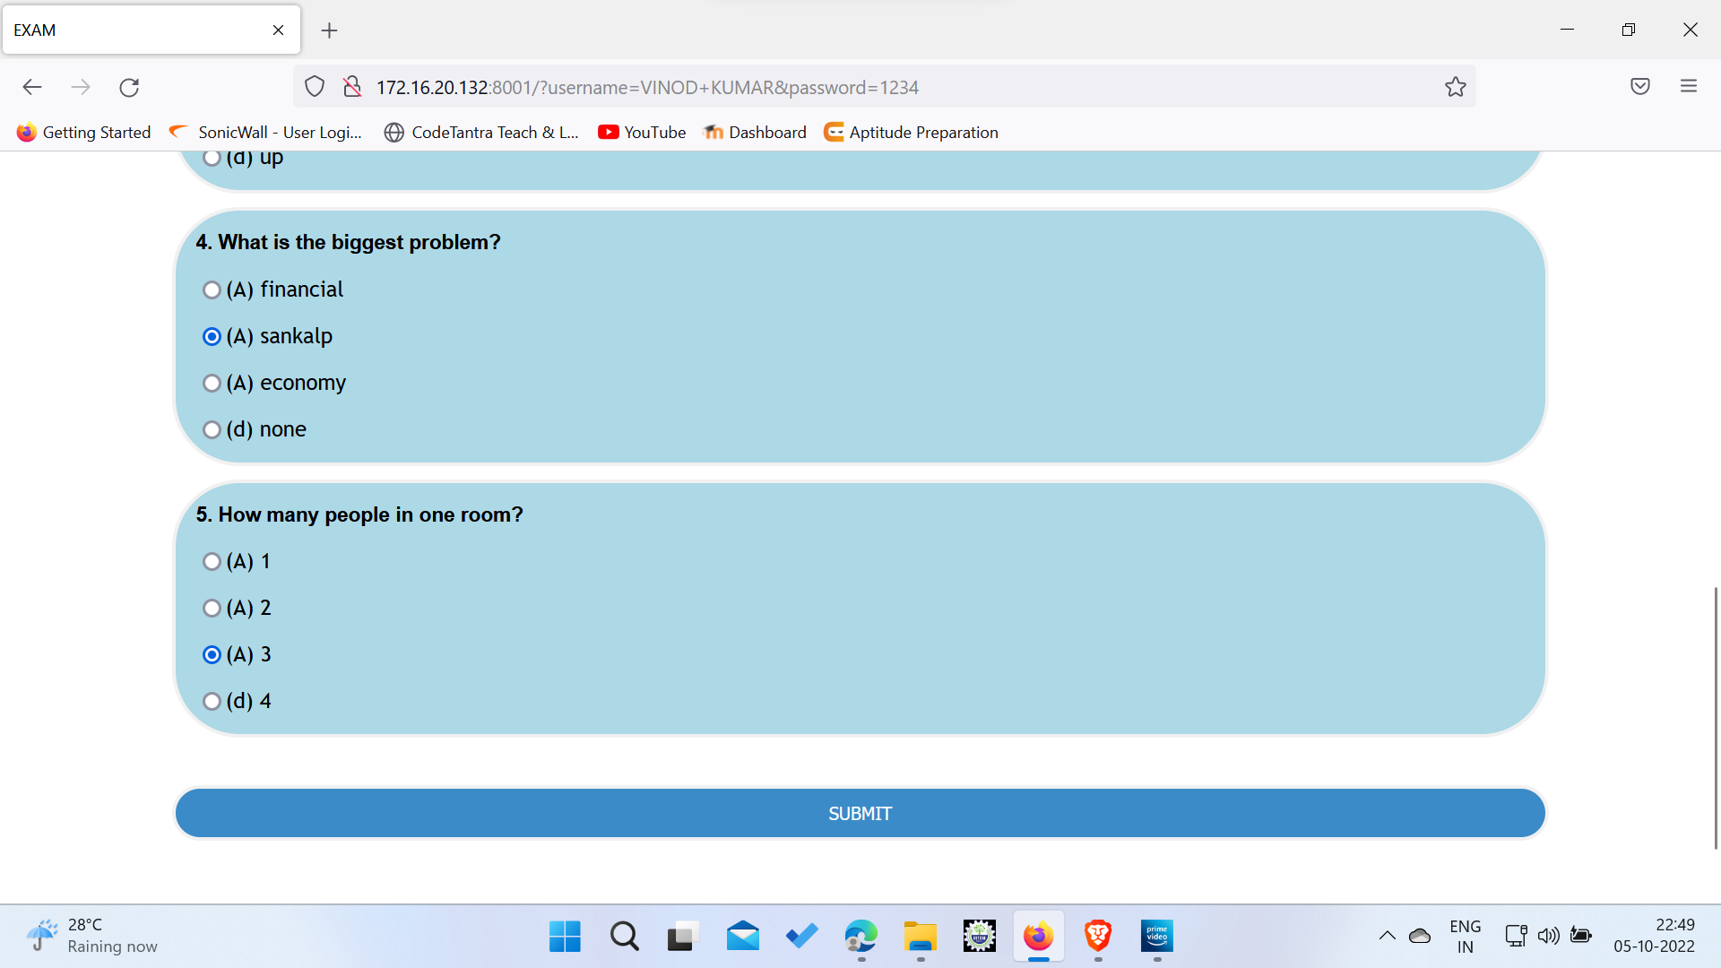

### 

### 

### 

### 

### 

### 4. Result Generation :

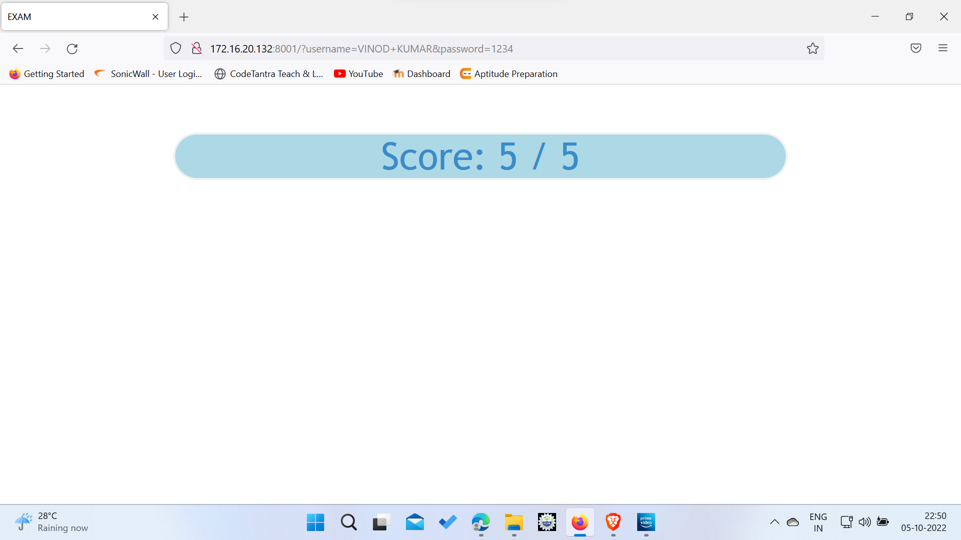

# **Thank You**